

**ArcGIS Experience Builder**

Create web apps you envision

ABT 182 - Advanced GIS

Instructor: Ali Moghimi

University of California, Davis

**Goal**

You will create an interactive ArcGIS Experience Builder web application focused on California wildfires. Using authoritative spatial datasets, your app will help users explore and compare fire history, burned area and severity, wildfire risk, and potential impacts. The finished app must support map-based exploration, filtering/querying, feature comparison, and clear communication of findings, and it must be fully usable on both desktop and mobile layouts.

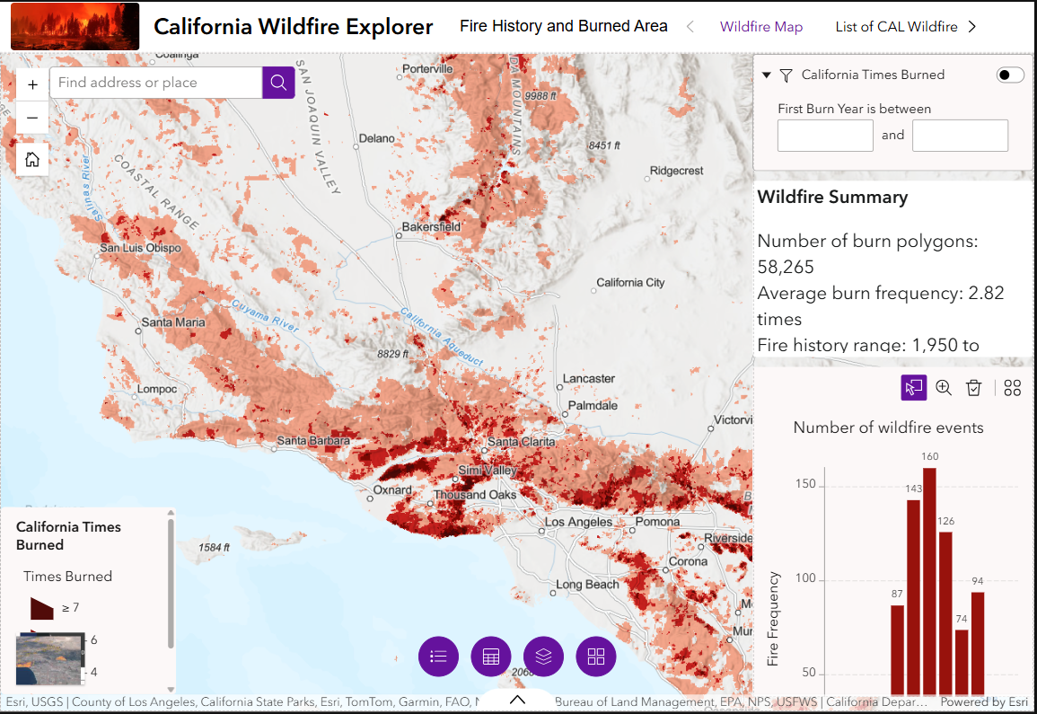

**Learning Objectives**

By completing this assignment, you will be able to:

* Design a multi-page Experience Builder app using templates and layout widgets
* Integrate 2D web maps and 3D web scenes
* Configure widget-to-widget communication using message actions
* Use dynamic content and data views to summarize wildfire information
* Design a clean UI with headers, menus, sections, and panels
* Optimize layouts for mobile devices
* Properly publish and share a web app in ArcGIS Online

**Note: At any time you want to stop working on your app, make sure to SAVE it before closing the browser window.**

**Step 1:**  
- Create a new Experience Builder using the Launchpad template, name it “CA Wildfire Explorer - [Your Name]”.

- Rename the first page to “Wildfire Map”

- Turn on the Header

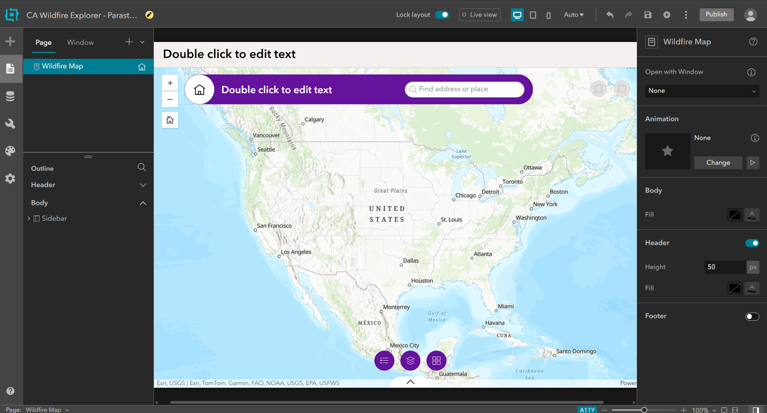

**Step 2:**

**Important Note in this step: Make sure that your selected data matches the source and image of the screenshots below.**

From the Data panel:

- Under Web Map, search for “California Wildfire Perimeters” published by CAL FIRE and add it as the primary 2D wildfire map.

- Under Layers, search for “USA Fire Burned Areas 1984–2022” published by Esri, and add it as a historical burned-area and severity layer.

- Under Web Scene, search for “CALFIRE – Southern California Fires January 2025” and add it as a 3D scene to provide recent terrain and fire context.

*Note: The datasets do not cover the same time period. This reflects real-world GIS workflows, where historical analysis layers are often combined with the most recent available 3D or situational data.*

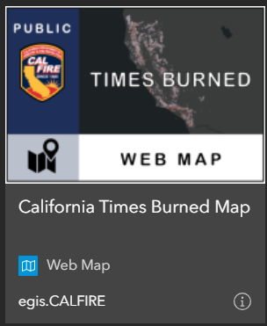 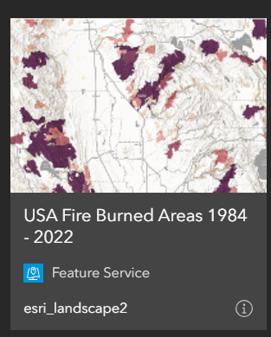 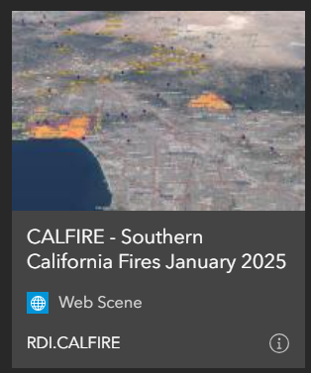

**Step 3:**

***Note: Make sure the “Lock Layout” at the top of the page is off, otherwise you won’t be able to see the header templates.***

From the header templates, choose header 1. Search for an image about wildfires in California and use it in the header. Set the title of the header to “California Wildfire Explorer”, and the subtitle to “Fire History and Burned Area”.

**Step 4:**

Click on the canvas, under “Content” in the right panel, set the California Times Burned web map as the default 2D map. Make sure the 3D web scene is available but not the default. Turn on “Live View” to test whether you can switch between maps.

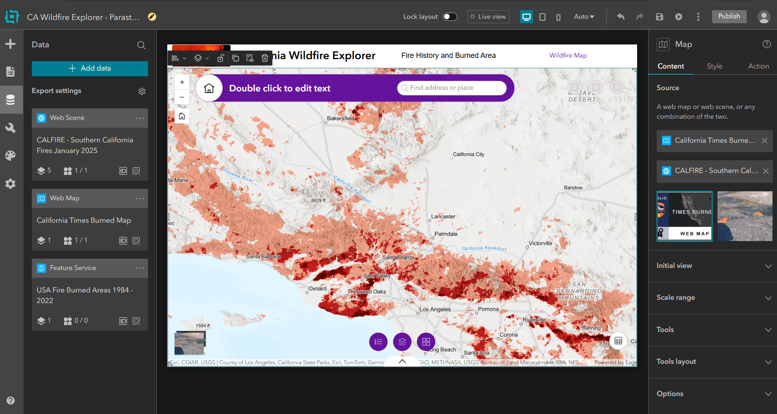

**Step 5:**

In the bottom of the page from the “Widget Controller”, select “Map Layer” (below screenshot).

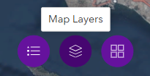

If you don’t see the “Map Layer” in the Widget Controller, add the “Map Layers” widget from the Insert (+) panel and place it in the Widget Controller. This gives users a single, compact control panel for turning wildfire layers on and off without cluttering the map.

In the Content pane of the “Map Layers” widget, set “Source” to “Interact with a Map” widget, and select the “Map” widget.

Under “Specify which layers will be displayed for each map”, click “California Times Burned Map” and toggle Customize layers ON. Customizing layers allows you to control exactly which wildfire layers users can interact with. Leave “Display layers generated at runtime” OFF. Runtime layers are created by analysis tools later; keeping this off prevents unexpected or confusing layers from appearing.

In the layer list, keep only the main wildfire layer (California Times Burned) checked.

Repeat steps 3–5 for CALFIRE – Southern California Fires January 2025, keeping only the Fire Perimeters layer checked to only preserve relevant layers to this assignment.

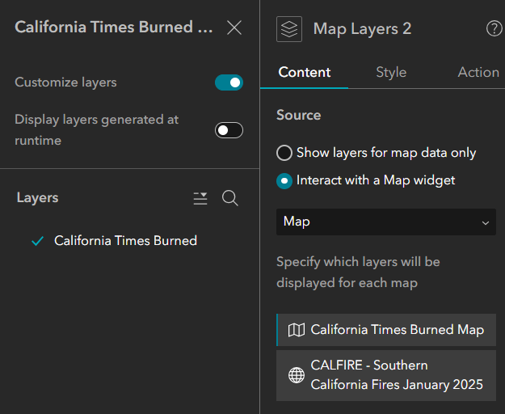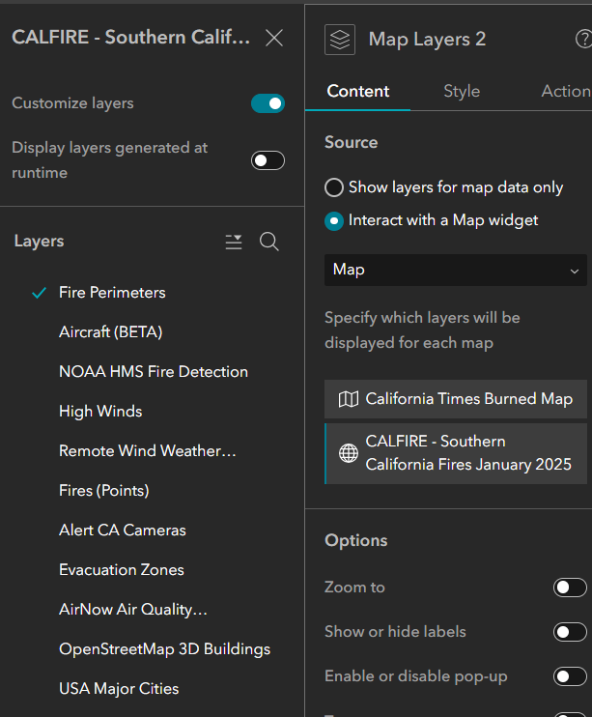

**Step 6:**

In this step, we want the users to see wildfire attributes in tabular form. This step also prepares the app for selection-based interaction (map ↔ table).

Add “Table” from “Insert Widget”, and place the Table inside the same Widget Controller at the bottom of the map. Then, select the Table widget, and in the Content pane, choose California Times Burned (from the 2D web map).

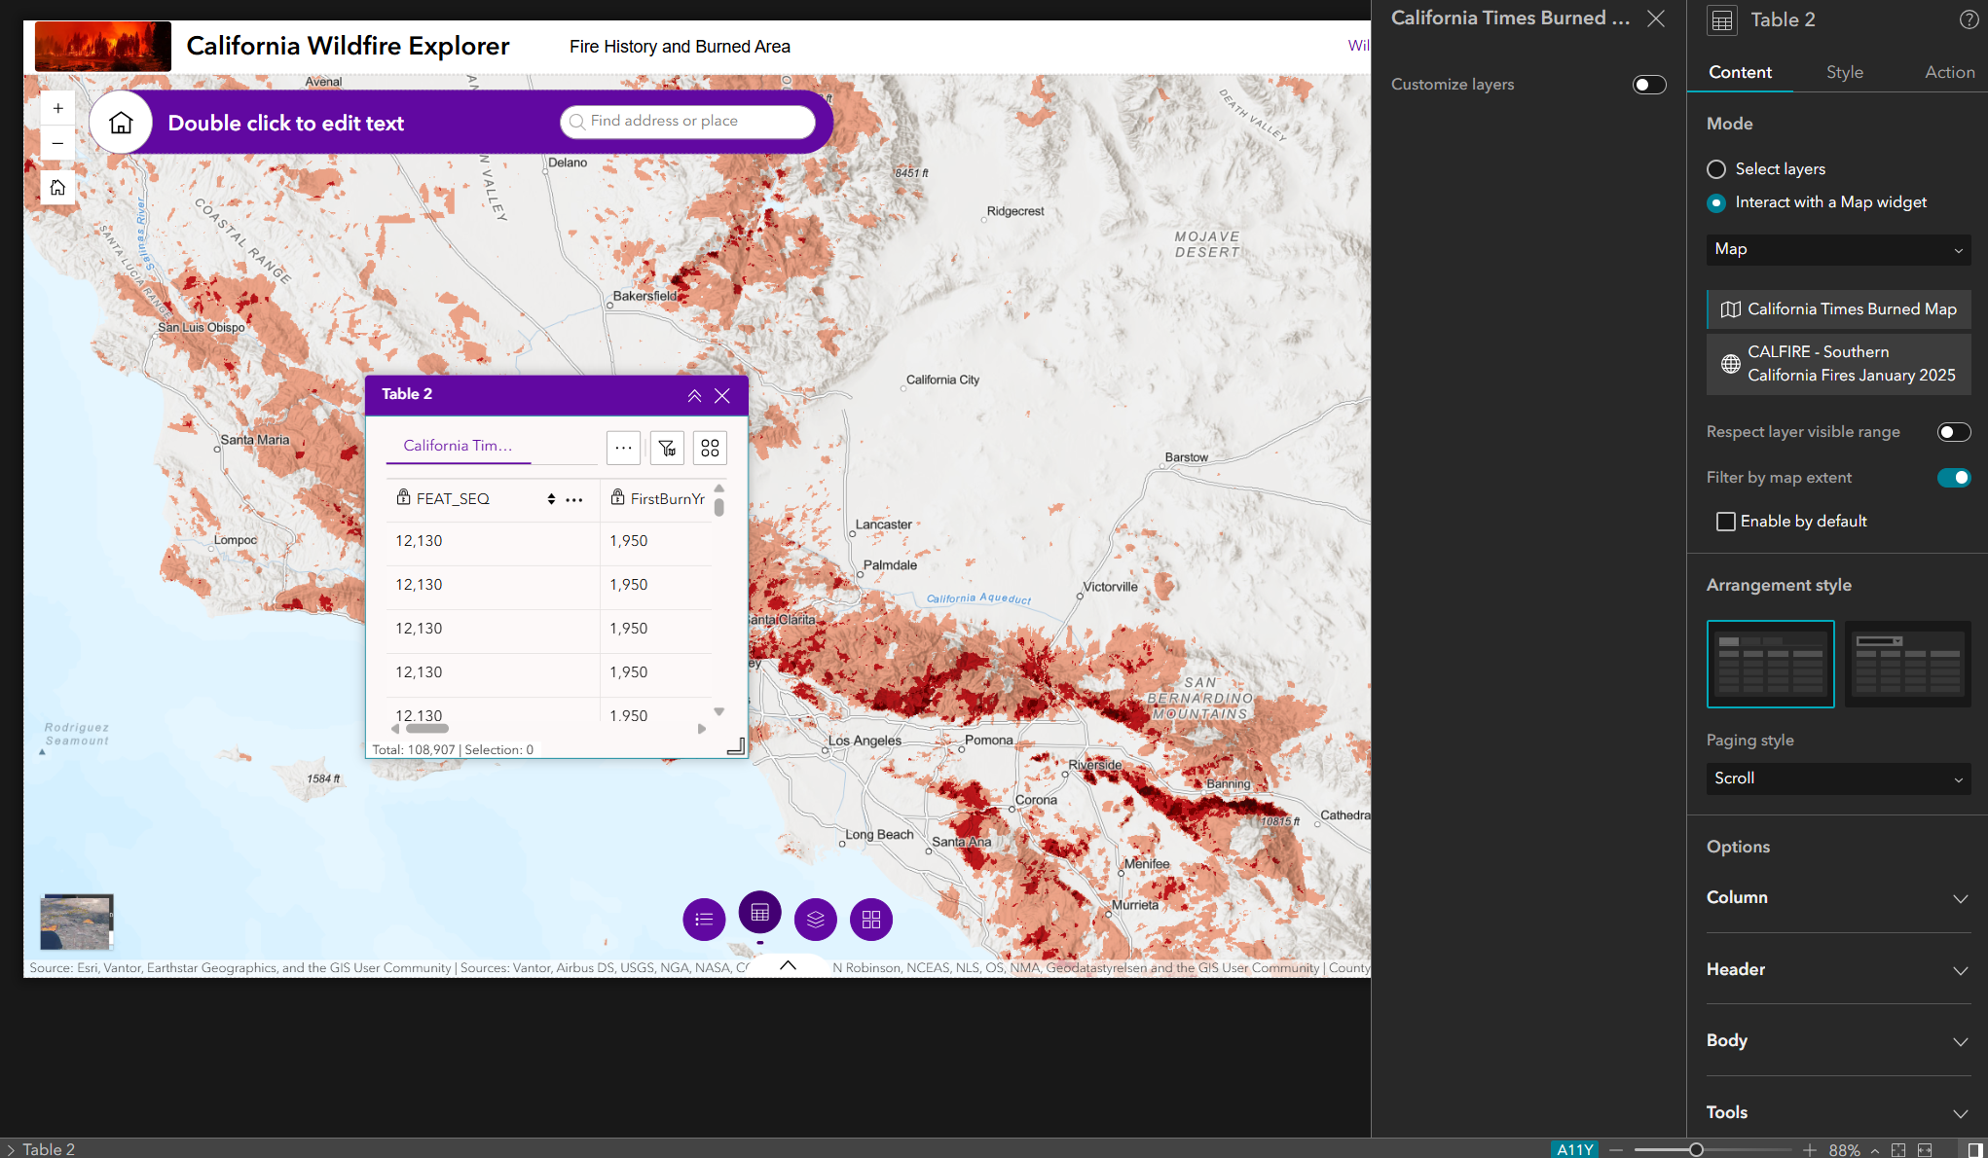  
  
Then, let’s only show some columns in the table that are more relevant (listed below):

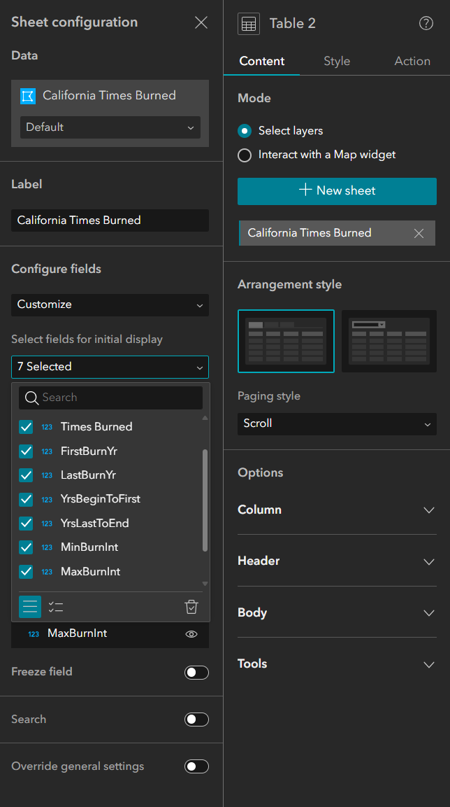

In order to do so, select the table widget, and on the Content pane in the right side, change the Mode from “Interact with a Map widget” to “Select Layers”, and select “+ New sheet”. Then, select California Times Burned web scene as your data in the opened panel, and change Configure fields to “Customize” to only keep these columns: *Times Burned, FirstBurnYr, LastBurnYr, MinBurnInt, MaxBurnInt, YrsBeginToFirst, YrsLastToEnd. These data show fire frequency, fire recurrence, temporal interpretation*.

We’re gonna add a new sheet and do the same thing with the CALFIRE 3d web map and selecting Fire Perimeter as the feature. For this table, keep these columns: *incident_name, FireDiscoveryDate, Percent Contained, displayStatus, Area (Acres)*.

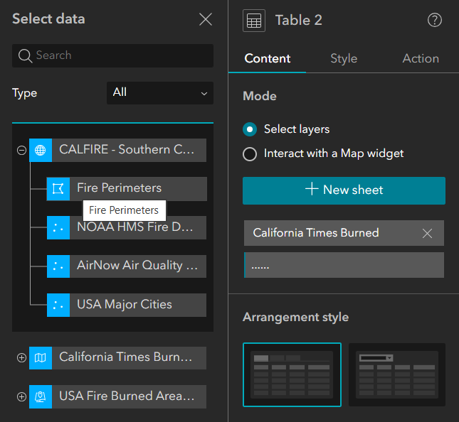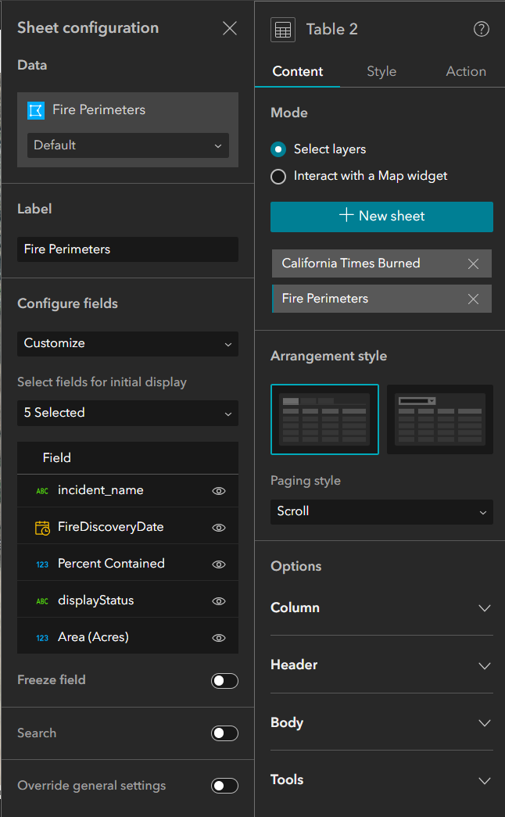

**Step 7:**

This step is where the table becomes interactive, not just informational. When a user clicks (selects) a row in the table, we want the map automatically zooms to the corresponding wildfire polygon and the selected fire briefly highlights on the map so the user can easily see it.  
  
To do that:  
Select Table 2 > select Action tab in the right pane > Click Add a trigger under Message action > choose Record selection changes > choose Map as target > select “Zoom to” as action.

Then add another action by clicking on “Add Action” > select “Map” as target > select Flash as action.

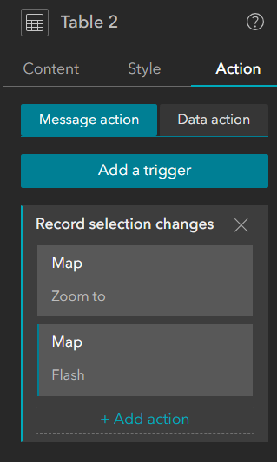

**Step 8:**

From the insert widget, insert “Legend” in the map. Modify its size and location in the map appropriately. Select the Legend widget, and in Content > Set Source → Interact with a Map widget > Select “Map”. Under the layer list keep only California Times Burned and Fire Perimeters. Uncheck everything else (wind, cities, basemap stuff). You’ll see when you change the maps, the legend also changes accordingly.

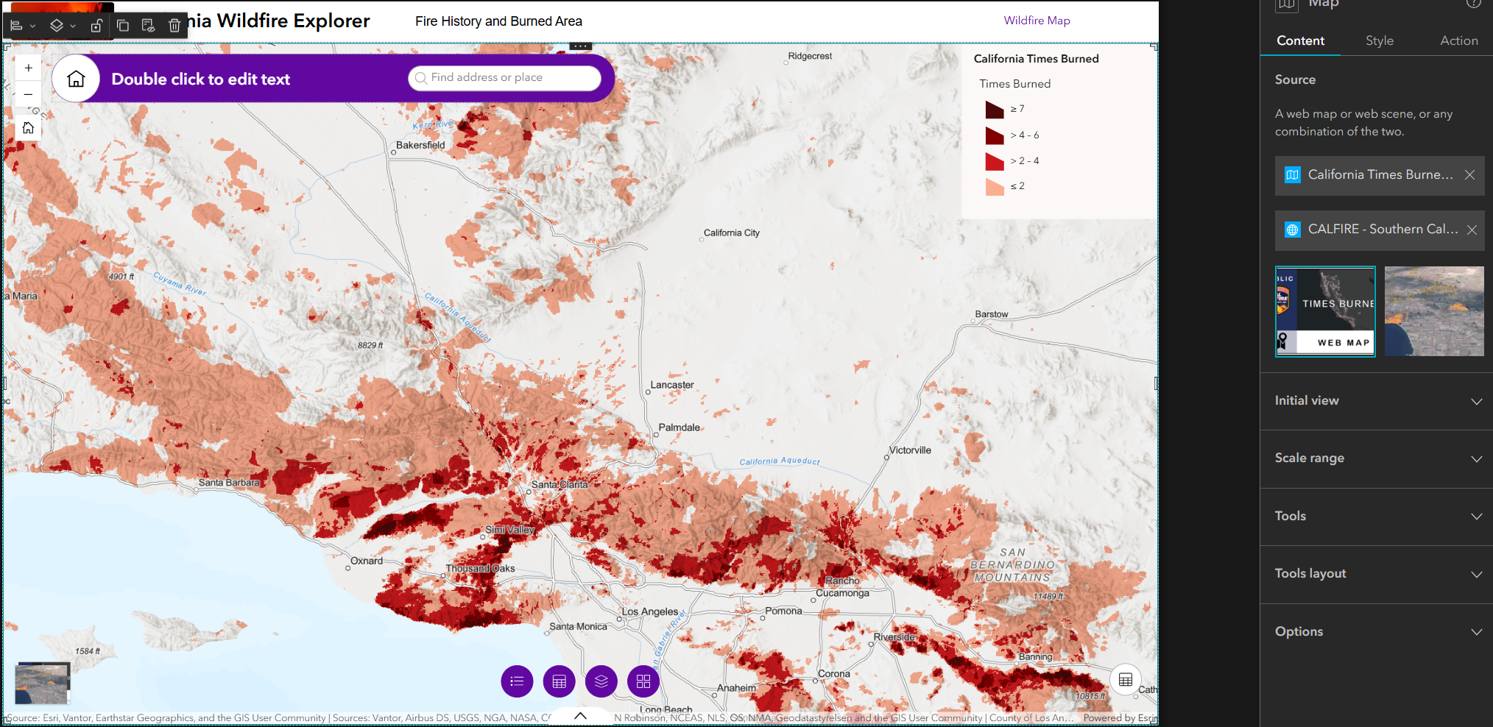

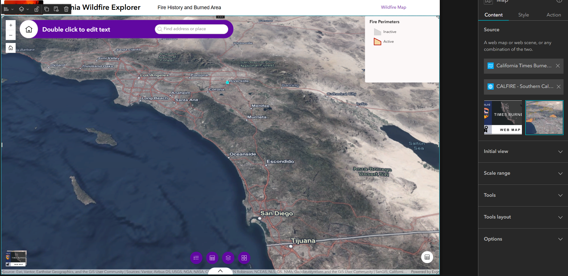

**Step 9:**

From the insert widget, add a text. Select the text and in the content, select California Times Burned. Using the dynamic content, we want to write something like below in the text box:

*Wildfire Summary*

*Number of burn polygons: {Count}*

*Average burn frequency: {Average_TimesBurned}*

*Fire history range: {Min_FirstBurnYr} – {Max_LastBurnYr}*

Firstly, change view to ‘Default’, not the ‘Selected features’. Default uses all features from *California Times Burned* (and later we can tie it to map extent), but Selected features only updates *after* the user clicks something (not what we want yet).

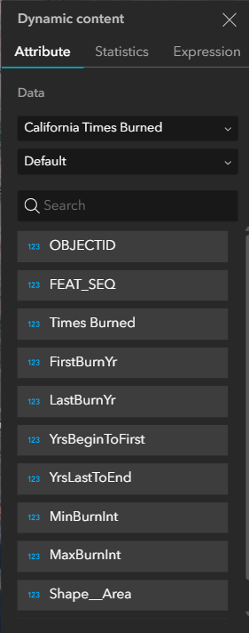 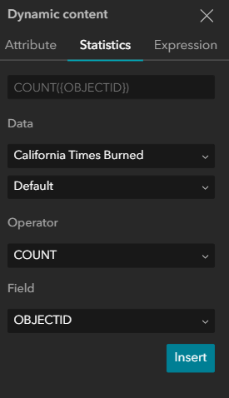 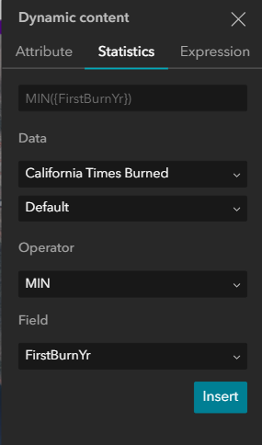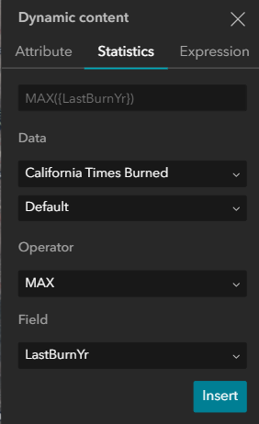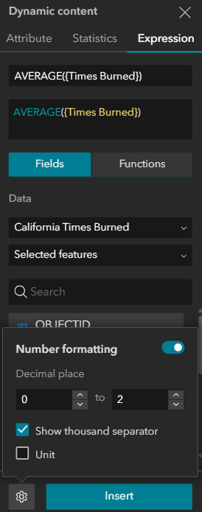

Pick a background for it as well. The textbox should look like this:

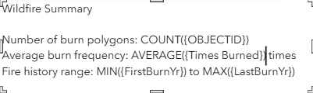

Now we want this text to be updated based on the extent of the map. However, Text widgets don’t support map-extent filtering directly. In order to do this, we create a Data View from the wildfire layer, enable map-extent filtering on that Data View, and use it as the data source for the Text widget. This allows the displayed statistics to reflect only the features visible in the current map view.

So from the data panel > select California Times Burned > select California Times Burned feature layer > under data views, create a view > Name it “TimesBurned_MapExtent”, and press “apply changes”. Don’t add any clauses, we don’t want attribute filters (like year ranges) right now.

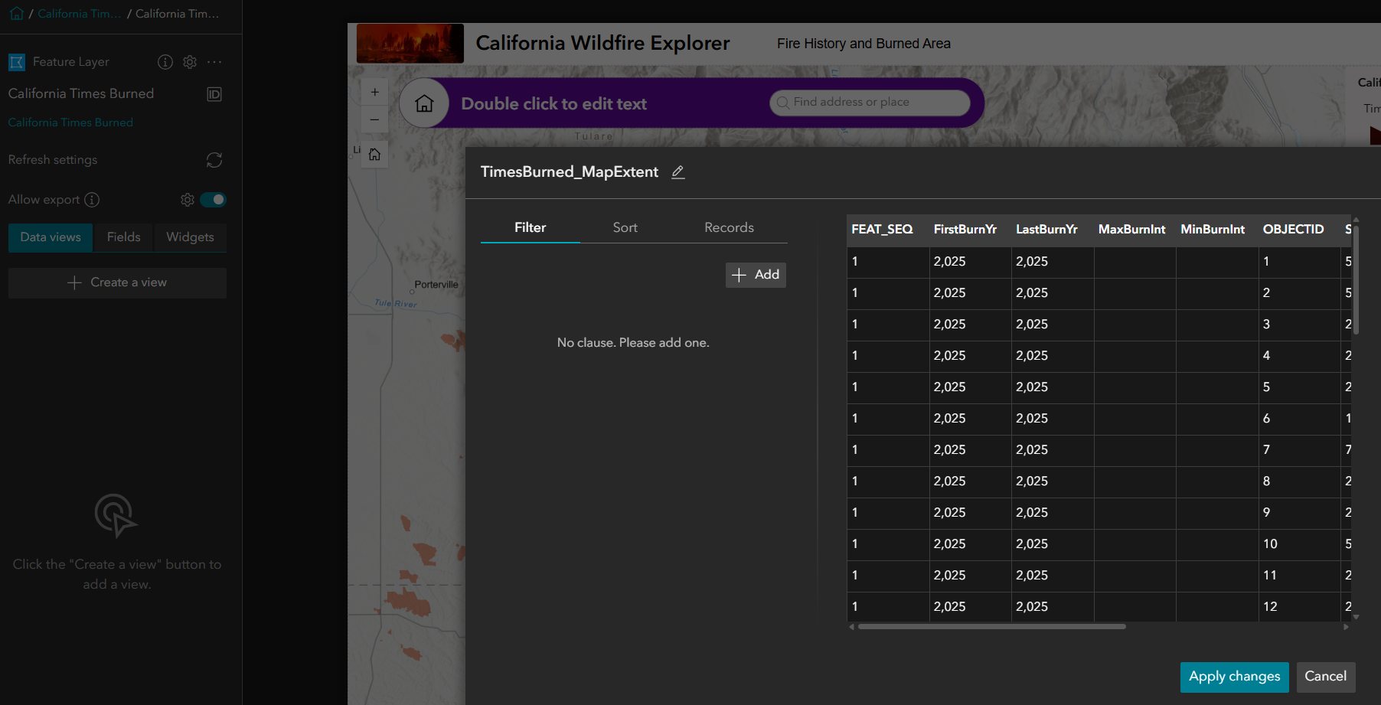

Now select the Text widget, and in the Content panel you should see “Connect to data” is on, and from the list of selected data choose the data view we just created.

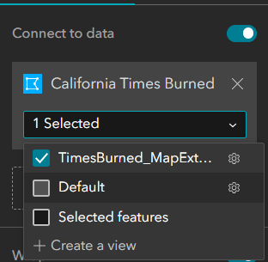

Because you changed the data source, you must reinsert the stats once again. For each line in the text > Click inside the text > Click {} Dynamic content > Go to Statistics > Make sure Data = TimesBurned_MapExtent and then Insert:  
COUNT → OBJECTID  
AVERAGE → Times Burned  
MIN → FirstBurnYr  
MAX → LastBurnYr

In the final step, click on the map in the canvas, in the Content panel select Add Trigger, and select extent changes as trigger and then select the California Times burned, and once it was added as data, click on “Data” that has been added to the panel under “Extent changes” and select the data view you just created.

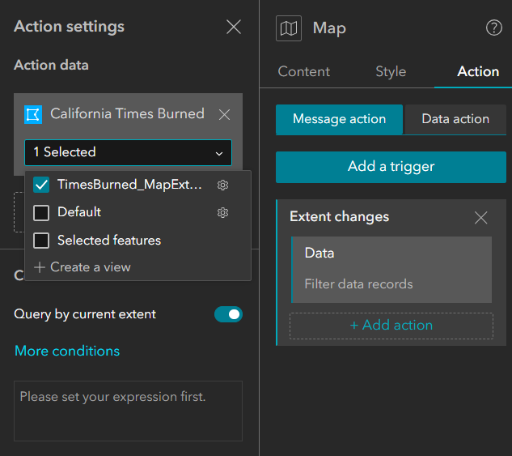

Test this feature in Live view to make sure it works.

*Note: We created a data view because the map widget can send extent-based filters, but text widgets can only read filtered data through a data view, not directly from the map.*

**Step 10:**

In this step, we want to create a chart. Same as the previous step, we first create a data view of the feature layer. So select the feature layer from the data panel, and create a data view named BurnedAreas_MapExtent. Then click on Map → under Action → under Data action → under Extent changes → click on + Add action > select Filter data records > select data > select feature layer > select the BurnedAreas_MapExtent.

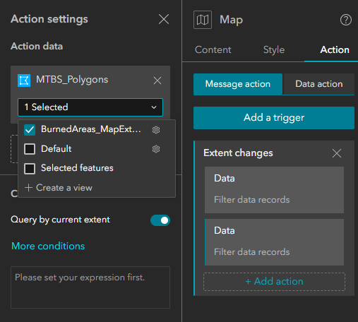

Now we want to add a chart that connects to this data view that we created from the feature layer, and updates when the map extent changes.

So from the insert widget, look for “Chart”, and add it to the map. Then click on it and under content, connect it to the BurnedAreas_MapExtent data view.

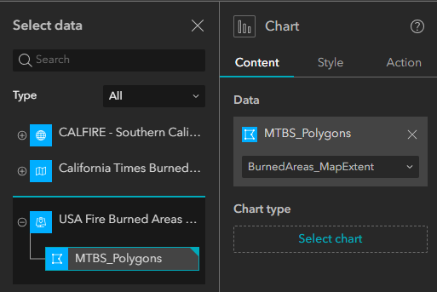

Then, select the column chart as the chart type because it’s best for comparing totals/counts across categories (years, fire types, etc.). Feel free to change the chart setting as you desire. You can use the below setting as an example:

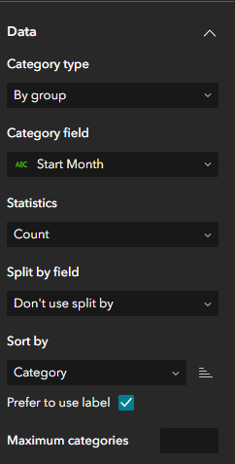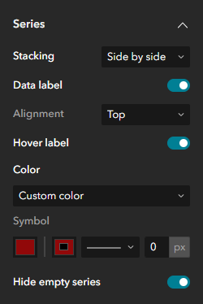 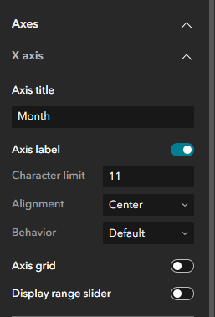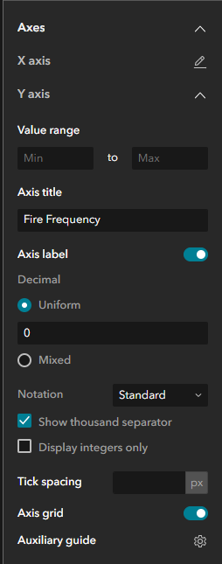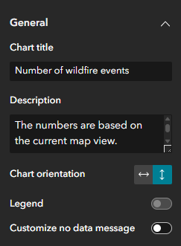

**Step 11:**

Add a new page, and find a webpage online, and add its link so the page in your web app shows the website page. Change the page name according to the website you’ve added. For example, I have added “List of California wildfires” from Wikipedia, and so I named my page “List of CAL Wildfires”.

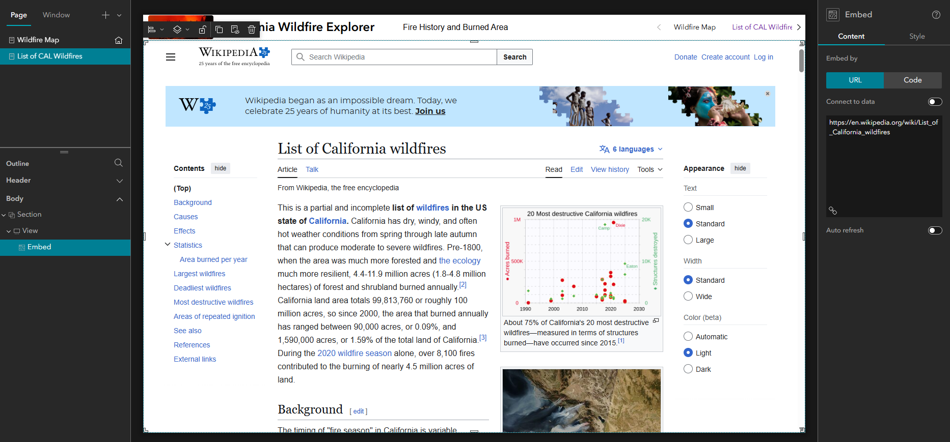

*Note: some websites such as CALFIRE have a security feature that you can’t embed their link to your web app. If you couldn’t embed a link, try another website and link.*

**Step 12:**

In the Wildfire map page, remove the default search bar, and instead, add for “Search” in the insert widget, and add it to the page.

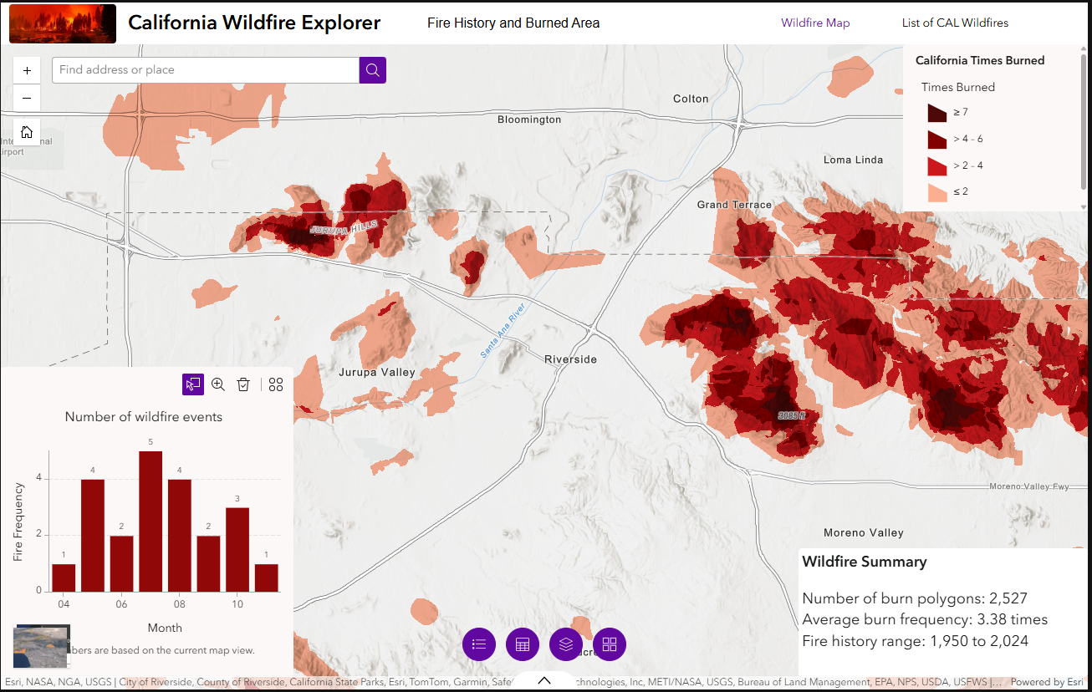

**Step 13:**

Now let’s add a filter that lets users filter the map (and charts, tables, text) by year. Click Insert (+) > Add Filter widget > in the content pane select “+ New filter” > add California Times Burned as data and keep its view to “Default”. Then, click on SQL Expression Builder > Add clause > and add the below clause:

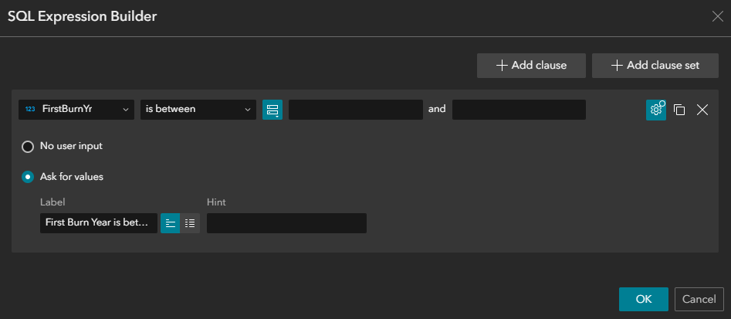

Once you do so, the filter will look like this on the map:

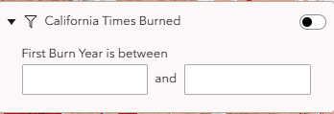

If you turn the toggle of the filter on and enter a start year and end year, you’ll only see the polygons between these years.

Once you add all, you can change the location of your widgets on the map so they look better.

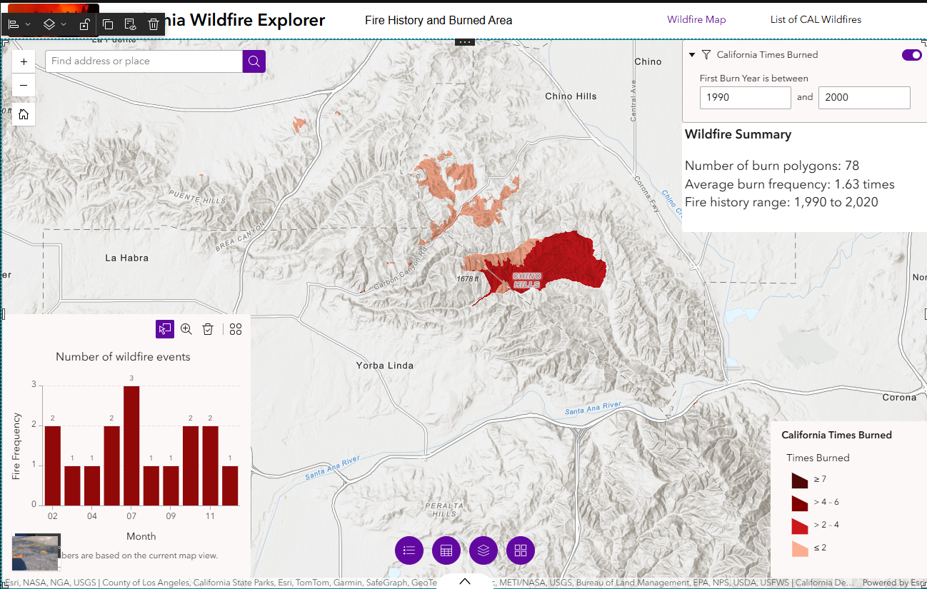

**Step 14:**

From the “Insert Widget” tab, look for “Column”, and drag and drop it on the page. Add the chart, text, and filter inside the column widget and place it in the right side of the page so your app looks more organized. Place the legend in the bottom left side of the page.



**Step 15:**

Now change the mobile view according to the tutorial, and fix its header, map widgets, etc. as you wish.

**Step 16:**

Once you’re done with your changes, save your project and check all features and widgets in the live view to see if they work okay.

Then, click on “Publish” next to the profile icon in the top right of the page.

**How to submit your assignment**

1- Open this page in your browser:  
<https://ucdavis.maps.arcgis.com/home/group.html?id=332290bfa6f94351aaa2ec5cdac4e363#overview>

Sign in using your kerberos id and password.

2- Click on the “Request to join” button to join the group.

3- In Experience Builder, click on the 3 vertical dots on the top right of the page, and click on “Change share settings”.

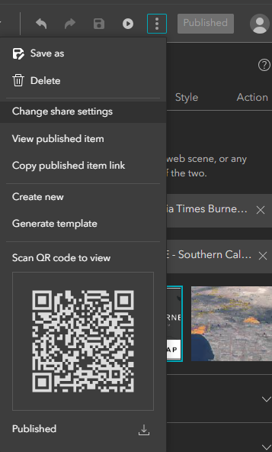

4- share with the “ABT 182 - Winter 2026” group.

